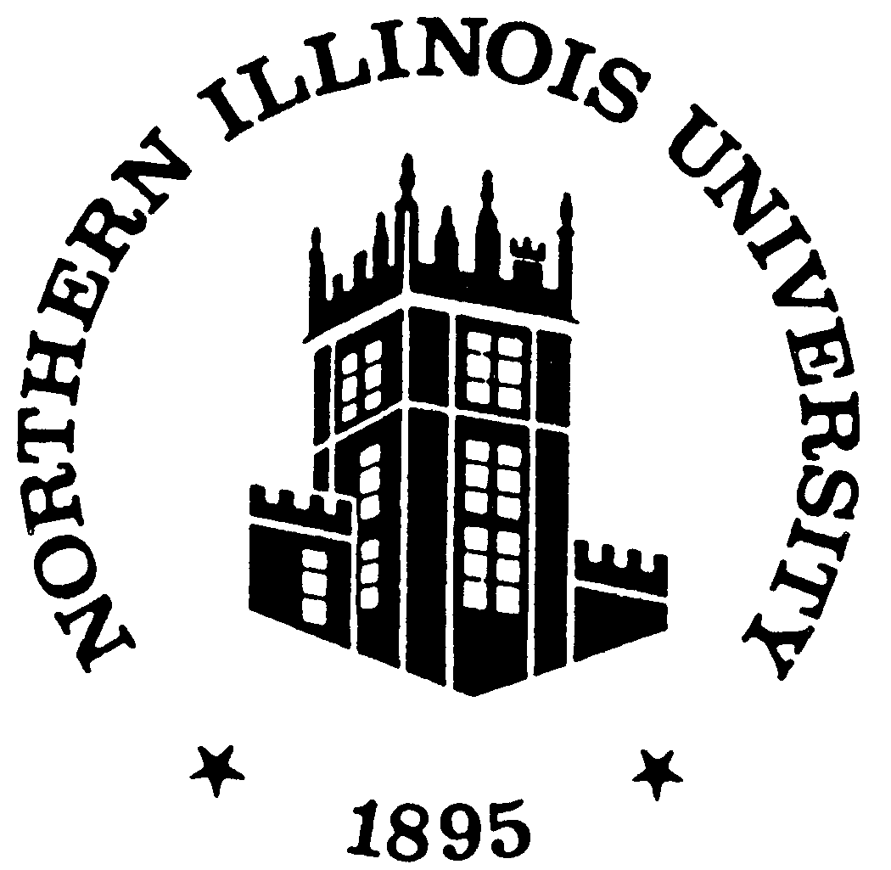

Regular Meeting
of the
Board of Trustees

January 7, 2025

Special Meeting of the
BOARD OF TRUSTEES OF NORTHERN ILLINOIS UNIVERSITY
1:30 p.m. – Tuesday – January 7, 2025
Board of Trustees Room
Altgeld 315

AGENDA

- Call to Order and Roll Call
- Verification of Quorum and Appropriate Notification of Public Meeting
- Meeting Agenda Approval Action i
- Chair's Comments/Announcements
- Public Comment*
- President’s Report No. 184
  - Membership Fee for Northern Illinois University to Join the Mountain West Conference…….... Action ……..1
- Other Matters
- Next Meeting Date
- Closed Session
- Adjournment
*Individuals wishing to make an appearance before the Board should consult the Bylaws of the Board of Trustees of Northern Illinois University, Article II, Section 4 – Appearances before the Board. Appearance request forms can be completed online in advance of the meeting or will be available in the Board Room the day of the meeting. For more information contact Crystal Doyle, ccoppel@niu.edu, Altgeld Hall 300, DeKalb, IL 60115, 815-753-1273.

Anyone needing special accommodations to participate in the NIU Board of Trustees meetings should contact Crystal Doyle, ccoppel@niu.edu or (815) 753-1273, as soon as possible.
Agenda Item 6.a. Action
January 7, 2025
MEMBERSHIP FEE FOR NORTHERN ILLINOIS UNIVERSITY TO JOIN THE MOUNTAIN WEST CONFERENCE
Summary: The university has accepted a formal offer to join the Mountain West Conference (“MWC”) as a football only member, effective July 1, 2026. Subject to Board of Trustees Regulations, the obligation of financial resources exceeding $500,000 requires Board of Trustees approval. The details of the transaction are articulated in the Background section of this item. The University is asking the Board to approve $2M for the required membership fee to join the MWC. In intercollegiate athletics, conference membership fees and exit fees are standard.
Conference realignment has become a reality in intercollegiate athletics. In addition to providing the university with additional revenue, the move to the MWC will allow the university to grow its strong football brand and reaffirm its commitment to the success of our student athletes.
Background: Northern Illinois University (“NIU”) has accepted an offer to join the Mountain West Conference (“MWC”) as a football only member, effective July 1, 2026. NIU will remain a full member of the Mid-American Conference (“MAC”) until June 30, 2026. NIU will pay a membership fee of $2M to join the MWC, payable in six annual installments of $333,33.35. The costs to support the transition to the MWC, including travel, staffing, rebranding, and exit fees will be primarily offset by increased revenues from multimedia rights, revenue distributions, and guarantees from the conference as well as anticipated enhancements in revenue from ticket sales and donations. After admission to the MWC, a ramp-up period of one year is anticipated before revenues fully reach projected levels. The university does not plan to use existing institutional funds to support the transition.
Starting no later than the 2026-27 academic year, the following institutions will have football programs in the Mountain West: United States Air Force Academy; University of Hawai’i at Mānoa; University of Nevada, Reno; University of New Mexico; Northern Illinois University; San José State University; University of Nevada, Las Vegas; University of Texas, El Paso and the University of Wyoming.
Recommendation: The University recommends that the Board of Trustees approve $2M for NIU to pay the membership fee to join the Mountain West Conference, effective July 1, 2026.

