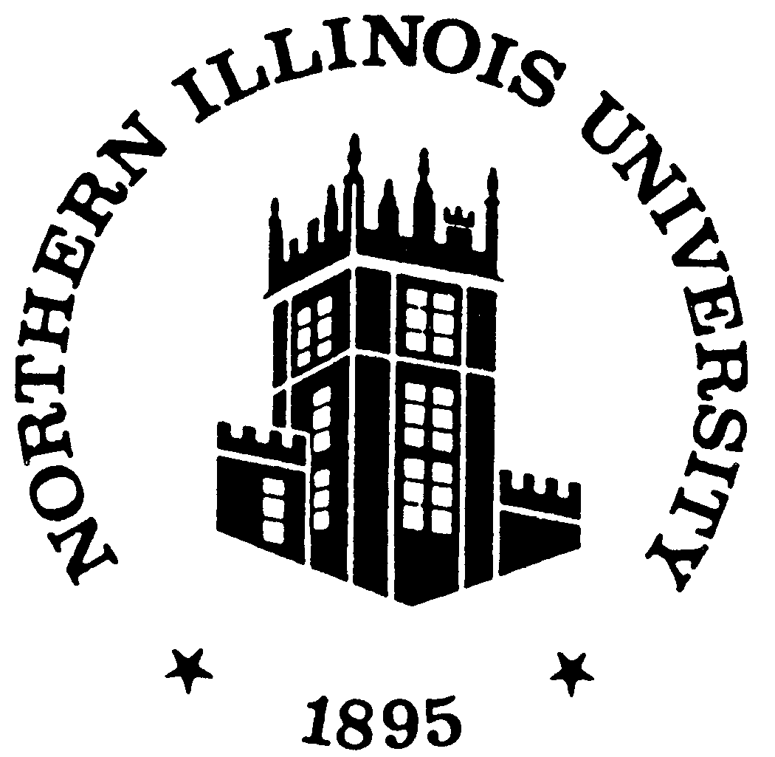

Board of Trustees

Academic Affairs, Student Affairs, and Personnel Committee

November 7, 2024

BOARD OF TRUSTEES OF NORTHERN ILLINOIS UNIVERSITY
Academic Affairs, Student Affairs, and Personnel Committee
8:30 a.m. – Thursday – November 7, 2024
Board of Trustees Room
Altgeld Hall 315

AGENDA

- Call to Order and Roll Call
- Verification of Quorum and Appropriate Notification of Public Meeting
- Meeting Agenda Approval Action i
- Review and Approval of Minutes of August 22, 2024 Action 1
- Chair's Comments/Announcements
- Public Comment*
- University Recommendations
- Recommendation for Faculty Tenure and/or Promotion Effective 2024-2025 ……………………………………….………………………………..……...Action…......4

- University Reports
  - Oversight of Academic Programs..…………….....................................Information ..........5

- Other Matters
- Next Meeting Date
- Adjournment
*Individuals wishing to make an appearance before the Board should consult the Bylaws of the Board of Trustees of Northern Illinois University, Article II, Section 4 – Appearances before the Board. Appearance request forms can be completed online in advance of the meeting or will be available in the Board Room the day of the meeting. For more information contact Crystal Doyle, ccoppel@niu.edu, Recording Secretary to the Board of Trustees, Altgeld Hall 300, DeKalb, IL 60115, 815-753-1273.
Anyone needing special accommodations to participate in the NIU Board of Trustees meetings should contact Crystal Doyle, ccoppel@niu.edu or (815) 753-1273, as soon as possible.

Minutes of the
Board of Trustees of Northern Illinois University
Academic Affairs, Student Affairs, and Personnel
Committee Meeting
August 22, 2024

Call to order and roll call
The meeting was called to order at 8:33 a.m. by Committee Vice Chair John Butler. This committee meeting was conducted in person.
Recording Secretary Liz Wright conducted a roll call.
Trustee Rita Athas: Present Committee Chair Veronica Herrero: Absent
Trustee Dennis Barsema: Present Trustee Aidan O’Brien: Present
Committee Vice Chair John Butler: Present Trustee Leland Strom: Present
Board Chair Montel Gayles: Present Trustee Eric Wasowicz: Present
Also present were President Lisa Freeman; Vice President and General Counsel and Board Parliamentarian Bryan Perry; Executive Vice President and Provost Laurie Elish-Piper; Board Liaison and Chief Strategy Officer Matt Streb; Vice President for Outreach, Engagement and Regional Development and Chief Engagement Office Rena Cotsones; Vice President for Enrollment Management, Marketing and Communications Sol Jensen; Vice President for Administration and Finance and Chief Financial Officer George Middlemist; Vice President for Research and Innovation Partnerships Richard Mocarski; Vice President for Student Affairs Clint-Michael Reneau; Assistant Vice Provost for Accreditation, Assessment and Evaluation Amy Buhrow; University Advisory Council Representatives Ben Creed and Larissa Garcia.

Verification of quorum and appropriate notice of public meeting
General Counsel Perry indicated the appropriate notification of the meeting had been provided pursuant to the Illinois Open Meetings Act and advised that a quorum was present.

Swearing in of Trustee Aidan O’Brien
Board Chair Montel Gayles conducted the swearing-in ceremony for the newly elected Student Trustee Aidan O’Brien. Aidan O’Brien remarked that he was extremely excited for this opportunity, honored to be student trustee and excited to work with the board over the next year.

Meeting agenda approval
Committee Vice Chair Butler asked for a motion to approve the agenda. Board Chair Gayles so moved, and Trustee Athas seconded. The motion was approved.

review and approval of minutes of May 9, 2024
Committee Vice Chair Butler asked for a motion to approve the minutes of May 9, 2024. Trustee Strom so moved, and Trustee Wasowicz seconded. The motion was approved.

chair’s comments/announcements
Committee Vice Chair Butler welcomed those in attendance and provided a brief overview of the agenda. He also recognized the members of the University Advisory Committee. Ben Creed welcomed the new student trustee Aidan O’Brien.
Committee Chair Herrero arrived at 8:41 a.m.

public comment
Committee Chair Herrero inquired to General Counsel Perry if any members of the public registered a request to address the board in accordance with state law and Board of Trustees bylaws. General Counsel Perry advised that no requests for public comment had been received.

university recommendations
Committee Chair Herrero asked Executive Vice President and Provost Laurie Elish-Piper to present the following university recommendations.
Agenda Item 8.a. Recommendations for Faculty Tenure and/or Promotion Effective 2024-2025
Committee Chair Herrero asked for a motion to approve item 8.a. Board Chair Gayles so moved, and Trustee Wasowicz seconded.
Committee Chair Herrero asked Ms. Wright to conduct a roll call vote.
Trustee Rita Athas: Yes Committee Chair Veronica Herrero: Yes
Trustee Dennis Barsema: Yes Trustee Aidan O’Brien: Abstain
Committee Vice Chair John Butler: Yes Trustee Leland Strom: Yes
Board Chair Montel Gayles: Yes Trustee Eric Wasowicz: Yes
The motion was approved.
Agenda Item 8.b. Request for Deletion of Integrated Minor in Marketing/M.S. in Digital Marketing
Committee Chair Herrero asked for a motion to approve item 8.b. Trustee Strom so moved, and Trustee Athas seconded. The motion was approved.

University Reports
Committee Chair Herrero asked Executive Vice President and Provost Laurie Elish-Piper to present the following informational items.
Agenda Item 9.a. Annual Listing of Changes Fiscal Year 2024
EVPP Elish-Piper introduced item 9.a. Annual Listing of Changes Fiscal Year 2024
Agenda Item 9.b. Dean of the College of Education Search Update
EVPP Elish-Piper introduced Agenda Item 9.b. Dean of the College of Education Search Update
Agenda Item 9.c. 2023-2024 Faculty Emeritus Recognition
EVPP Elish-Piper introduced Agenda Item 9.b. 2023-2024 Faculty Emeritus Recognition
Agenda Item 9.d. HLC Accreditation Site Visit Update
EVPP Elish-Piper gave a presentation on the Higher Learning Commission accreditation site visit.

Other Matters
Committee Chair Herrero asked if there were any other matters. There were none.

Next meeting Date
The next meeting of the Academic Affairs, Student Affairs, and Personnel Committee will be Thursday, November 7, 2024.

adjournment
Committee Chair Herrero asked for a motion to adjourn. Trustee Barsema so moved, and Trustee Wasowicz seconded.
Committee Chair Herrero asked Ms. Wright to conduct a roll call vote.
Trustee Rita Athas: Yes Committee Chair Veronica Herrero: Yes
Trustee Dennis Barsema: Yes Trustee Aidan O’Brien: Yes
Committee Vice Chair John Butler: Yes Trustee Leland Strom: Yes
Board Chair Montel Gayles: Yes Trustee Eric Wasowicz: Yes
The motion was approved.
Meeting adjourned at 9:16 a.m.

Respectfully submitted,
Liz Wright
Recording Secretary

In compliance with Illinois Open Meetings Act 5 ILCS 120/1, et seq, a verbatim record of all Northern Illinois University Board of Trustees meetings is maintained by the Board Recording Secretary and is available for review upon request. The minutes contained herein represent a true and accurate summary of the Board proceedings.

Agenda Item 7.a. Action
November 7, 2024
RECOMMENDATION FOR FACULTY TENURE AND/OR
PROMOTION EFFECTIVE 2024-2025
NAME COLLEGE/DEPARTMENT/SCHOOL
Hired at the Rank of Associate Professor with Tenure
Matthew Deitch Earth, Atmosphere and Environment
Recommendation: The University recommends that the Academic Affairs, Student Affairs, and Personnel Committee endorse this request and that the President forward it by means of the President’s Report to the Board of Trustees for approval at its meeting special meeting on November 7, 2024.
Agenda Item 8.a. Information
November 7, 2024
OVERSIGHT OF ACADEMIC PROGRAMS
Northern Illinois University engages in numerous processes to monitor the quality of its academic degree programs and to inform planning and decision-making about the programs. Processes internal to the university include program review and the assessment of learning outcomes, which are required of all programs by our regional accreditor the Higher Learning Commission and by the Illinois Board of Higher Education. Processes that include external constituencies or external indicators include external reviews of dissertations, accreditation, licensure and certification examinations, and advisory committees.
Internal Processes
Program Review: NIU has a long-standing history of conducting thorough reviews of its academic programs and research and public service centers through the program review process. The review schedule for programs that do not have disciplinary and/or college accreditation is eight years; programs with disciplinary and/or college accreditation have reviews scheduled to align with accreditation cycles (cycle lengths vary between five and ten years). Departments scheduled for review prepare in-depth self-study documents, which may incorporate data collected by the program, data provided by other university offices, and information from external indicators or constituencies. Programs with external disciplinary accreditation may substitute accreditation self-study reports for the program review self-study. Program review documents are reviewed at the college level (or division level when the program or center is not housed within a college). Review results are summarized via a standardized Illinois Board of Higher Education format and submitted to the Executive Vice President and Provost (EVPP). The EVPP provides the summaries to the Academic Planning Council and the Board of Trustees as an information item.
The programs in the College of Education reviewed in 2023-2024 were the:
M.S. in Athletic Training
The programs in the College of Engineering and Engineering Technology reviewed in 2023-2024 were the:
B.S. in Biomedical Engineering
B.S. in Electrical Engineering
B.S. in Engineering Technology
B.S. in Industrial and Systems Engineering
B.S. in Mechanical Engineering
B.S. in Mechatronics Engineering
M.S. in Electrical Engineering
B.S. in Engineering Technology
M.S. in Industrial and Systems Engineering
M.S. in Industrial Management and Technology
M.S. in Mechanical Engineering
Ph.D. in Electrical Engineering
Ph.D. in Industrial and Systems Engineering
The programs in the College of Health and Human Sciences reviewed in 2023-2024 were the:
B.S. in Rehabilitation and Disability Services
M.S. in Rehabilitation Counseling
The programs in the College of Liberal Arts and Sciences reviewed in 2023-2024 were the:
B.S./B.A. in Economics
B.S./B.A. in History
M.A. in Economics
M.A. in History
Ph.D. in Economics
Ph.D. in History
The programs in the College of Visual and Performing Arts reviewed in 2023-2024 were the:
B.A. in Music
B.M. in Music
M.M. in Music
P.C. in Music
The centers reviewed in 2023-2024 were the:
Center for the Study of Family Violence and Sexual Assault
Center for Burma Studies
Institute for the Environment, Sustainability and Energy
The programs in the College of Visual and Performing Arts scheduled for review in 2023-2024 but granted an extension to 2024-2025 were the:
B.A./B.S. in Art
B.S.Ed. in Art and Design Education
B.A. in Art History and Visual Studies
B.F.A. in Art Studio and Design
B.F.A. in Dance Performance
B.F.A. in Theatre Arts
B.A. in Theatre Studies
M.A. in Art
M.F.A. in Art and Design
M.S. in Art and Design Education
M.F.A. in Theatre Arts
Ph.D. in Art and Design Education
The information submitted to the IBHE to meet its reporting requirement for 2023-2024 has also been forwarded to the Board of Trustees under separate cover.
Assessment of Learning Outcomes: All NIU degree programs engage in the systematic assessment of student learning. The overall assessment process is designed to inform program review. The University Assessment Panel reviews all assessment plans which outline the methods, processes, and time frames for the implementation of the plans. Each year, every program prepares an Annual Assessment Update that provides a snapshot of the last 12 months assessment-related activities, the evidence gathered from the activities, and the actions taken on the evidence. The annual assessment updates are submitted to Accreditation, Assessment, and Evaluation. Accreditation, Assessment, and Evaluation staff review the updates using standardized rubrics, provide feedback to the individual programs, and prepare a consolidated report on the extent to which the criteria for the updates were met. Halfway through the program review cycle, programs submit a Mid-cycle Status Report on the assessment plan (including its use and evolution over this period) for review by the University Assessment Panel. The panel uses a standardized rubric and reporting form to provide feedback to the programs.
External Processes
Accreditation: Accreditation is a “process of external quality review created and used by higher education to scrutinize colleges, universities and programs for quality assurance and quality improvement” (Overview of U.S. Accreditation, CHEA, 2009), and more than 20 specialized agencies accredit NIU programs across seven academic colleges. Accreditation is earned through a comprehensive process that involves self-study, peer review, site visits and action from the accrediting agency’s commission affirming that threshold standards have been met. These programs were reviewed by disciplinary accreditors in 2023-2024:
College of Business/AACSB
All College of Business degree programs
Decision: Extension of accreditation to 2029
College of Business Department of Accountancy/AACSB Accounting
All College of Business Department of Accountancy degree programs
Decision: Extension of accreditation to 2029
College of Law/American Bar Association (ABA)
Doctor of Jurisprudence
Decision: Northern Illinois University College of Law remains an approved law school. Next review in 2033-2034
Licensure and Certification Examinations: Graduates from NIU’s accountancy, clinical and school psychology, counseling, law, teacher education and health sciences programs take licensure or certification examinations that permit them to practice in their discipline. The results of these examinations give programs the means to benchmark NIU graduates’ performance against state and/or national performance rates.
Advisory Committees: Many programs and departments engage in periodic discussion with alumni, employers and/or professionals in the discipline who participated on advisory committees. These individuals provide feedback related to the performance and competencies of the program’s alumni, curricular content and new trends in the discipline, which is used in numerous ways to ensure that programs are preparing students with contemporary knowledge and skills.

